**Jalen Powell**

**Bio 103**

**Lab J Background**

**It’s All in the Genes**

**Understanding Basic Mendelian Genetics**

**The Mendelian Concept of a Gene**

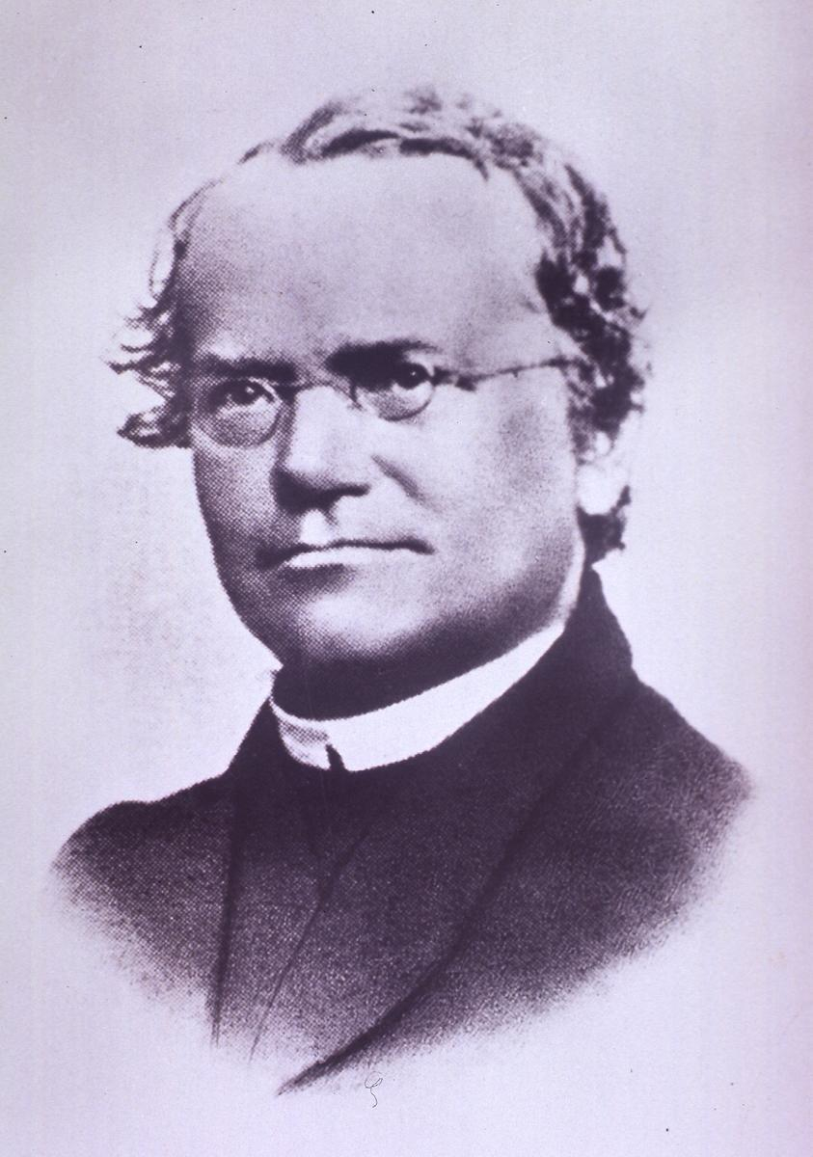

Gregor Mendel

Image Courtesy of the National Library of Medicine

In the 1860’s, an Austrian monk named Gregor Mendel introduced a new theory of inheritance based on his experimental work with pea plants. Prior to Mendel, most people believed inheritance was due to a blending of parental ‘essences’, much like how mixing blue and yellow paint will produce a green color. Mendel instead believed that heredity is the result of discrete units of inheritance, and every single unit (or gene) was independent in its actions in an individual’s genome. According to this Mendelian concept, inheritance of a trait depends on the passing-on of these units. For any given trait, an individual inherits one gene from each parent so that the individual has a pairing of two genes. We now understand the alternate forms of these units as **alleles**. If the two alleles that form the pair for a trait are identical, then the individual is said to be **homozygous** and if the two genes are different, then the individual is **heterozygous** for the trait.

Based on his pea plant studies, Mendel proposed that traits are always controlled by single genes. However, modern studies have revealed that most traits in humans are controlled by multiple genes as well as environmental influences and do not necessarily exhibit a simple Mendelian pattern of inheritance (see “Mendel’s Experimental Results”).

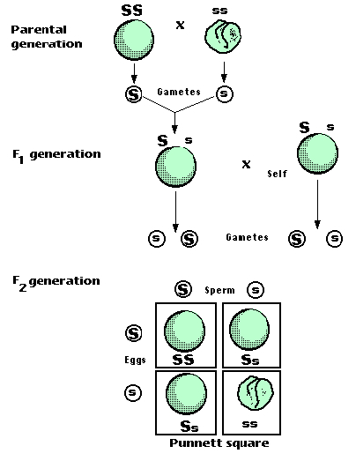**Mendel’s Experimental Results**

Mendel carried out breeding experiments in his monastery’s garden to test inheritance patterns. He selectively cross-bred common pea plants (Pisum sativum) with selected traits over several generations. After crossing two plants which differed in a single trait (tall stems vs. short stems, round peas vs. wrinkled peas, purple flowers vs. white flowers, etc), Mendel discovered that the next generation, the “F1” (first filial generation), was comprised entirely of individuals exhibiting only one of the traits. However, when this generation was interbred, its offspring, the “F2” (second filial generation), showed a 3:1 ratio- three individuals had the same trait as one parent and one individual had the other parent’s trait

Mendel then theorized that genes can be made up of three possible pairings of heredity units, which he called ‘factors’: AA, Aa, and aa. The big ‘A’ represents the **dominant** factor and the little ‘a’ represents the **recessive** factor. In Mendel’s crosses, the starting plants were homozygous AA or aa, the F1 generation were Aa, and the F2 generation were AA, Aa, or aa. The interaction between these two determines the physical trait that is visible to us.

Mendel’s Law of Dominance predicts this interaction; it states that when mating occurs between two organisms of different traits, each offspring exhibits the trait of one parent only. If the dominant factor is present in an individual, the dominant trait will result. The recessive trait will only result if both factors are recessive.

**Mendel’s Laws of Inheritance**

Mendel’s laws are fundamental to a basic understanding of genetics. The seven traits that Mendel investigated in pea plants were either dominant (A) or recessive (a). His laws are based upon his initial findings that one allele is dominant to another allele. Mendel’s observations and conclusions are summarized in the following two principles, or laws.

* **Law of Segregation**

Mendel’s Law of Segregation states that during the formation of gametes, the alleles responsible for each trait separate so that each gamete contains only one allele for that trait. Thus, female and male parents contribute equally in the formation of an embryo.

* **Law of Independent Assortment**

Mendel’s Law of Independent Assortment states that every trait is inherited independently of every other trait carried on a different chromosome. As a result of the law of independent assortment, all of the possible combinations of the alleles can occur in gametes.

**Punnett Squares**

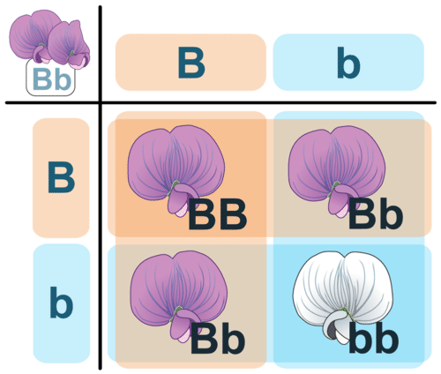

A Punnett square is a chart that allows you to easily determine the expected percentage of different genotypes in the offspring of two parents. An example of a Punnett square for pea plants is shown in Figure above. In this example, both parents are heterozygous for flower color (Bb). The gametes produced by the male parent are at the top of the chart, and the gametes produced by the female parent are along the side. The different possible combinations of alleles in their offspring are determined by filling in the cells of the Punnett square with the correct letters (alleles). At the link below, you can watch an animation in which Reginald Punnett, inventor of the Punnett square, explains the purpose of his invention and how to use it.

<http://www.dnalc.org/view/16192-Animation-5-Genetic-inheritance-follows-rules-.html>

An explanation of Punnett squares can be viewed at:

<http://www.youtube.com/watch?v=D5ymMYcLtv0>

Another example of the use of a Punnett square can be viewed at:

<http://www.youtube.com/watch?v=nsHZbgOmVwg>

This Punnett square (figure above) shows a cross between two heterozygotes, Bb. Do you know where each letter (allele) in all four cells comes from? Two pea plants, both heterozygous for flower color, are crossed. The offspring will show the dominant purple coloration in a 3:1 ratio. Or, about 75% of the offspring will be purple. Keep in mind that **expected results** are specific figures and are not the result of chance. However, in nature the expected results may not agree with the observed results. **Observed results** are those that appear in the offspring because of random combinations of the genes.

**Predicting Offspring Genotypes**

In the cross shown in Figure above, you can see that one out of four offspring (25 percent) has the genotype BB, one out of four (25 percent) has the genotype bb, and two out of four (50 percent) have the genotype Bb. These percentages of genotypes are what you would expect in any cross between two heterozygous parents. Of course, when just four offspring are produced, the actual percentages of genotypes may vary by chance from the expected percentages. However, if you considered hundreds of such crosses and thousands of offspring, you would get very close to the expected results, just like tossing a coin.

**Predicting Offspring Phenotypes**

You can predict the percentages of phenotypes in the offspring of this cross from their genotypes. B is dominant to b, so offspring with either the BB or Bb genotype will have the purple-flower phenotype. Only offspring with the bb genotype will have the white-flower phenotype. Therefore, in this cross, you would expect three out of four (75 percent) of the offspring to have purple flowers and one out of four (25 percent) to have white flowers. These are the same percentages that Mendel got in his first experiment.

**Determining Missing Genotypes**

A Punnett square can also be used to determine a missing genotype based on the other genotypes involved in a cross. Suppose you have a parent plant with purple flowers and a parent plant with white flowers. Because the b allele is recessive, you know that the white-flowered parent must have the genotype bb. The purple-flowered parent, on the other hand, could have either the BB or the Bb genotype. The Punnett square in Figure below shows this cross. The question marks (?) in the chart could be either B or b alleles.

**Test cross with a Punnett square**

**White Flowered Parent**

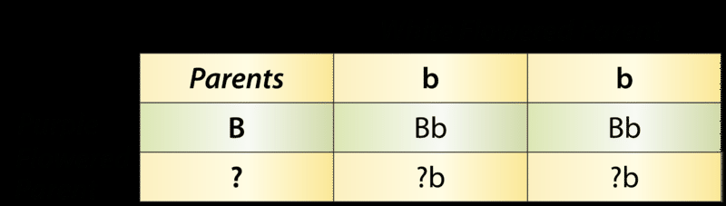

**Purple Flowered Parent**

Punnett Square: Cross Between White-Flowered and Purple-Flowered Pea Plants. This Punnett square shows a cross between a white-flowered pea plant and a purple-flowered pea plant. This is a **monohybrid cross**, representing the mating between two organisms that involves one specific trait. Can you fill in the missing alleles? What do you need to know about the offspring to complete their genotypes?

Can you tell what the genotype of the purple-flowered parent is from the information in the Punnett square? No; you also need to know the genotypes of the offspring in row 2.

What if you found out that two of the four offspring have white flowers? Now you know that the offspring in the second row must have the bb genotype. One of their b alleles obviously comes from the white-flowered (bb) parent, because that’s the only allele this parent has. The other b allele must come from the purple-flowered parent. Therefore, the parent with purple flowers must have the genotype Bb.

**Punnett Square for Two Characteristics**

When you consider more than one characteristic at a time, using a Punnett square is more complicated. This is because many more combinations of alleles are possible. For example, with two genes each having two alleles, an individual has four alleles, and these four alleles can occur in 16 different combinations. This is illustrated for pea plants in Figure below. In this cross, known as **a dihybrid cross**, both parents are heterozygous for pod color (Gg) and pod form (Ff).

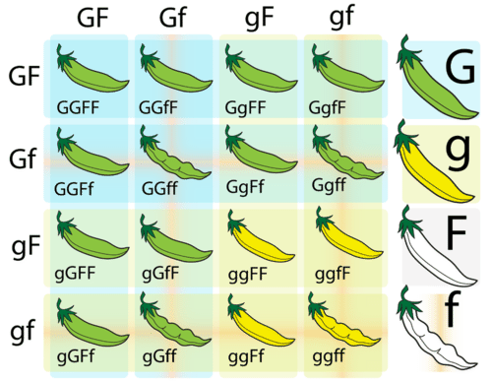

Punnett Square for Two Characteristics. This Punnett square represents a cross between two pea plants that are heterozygous for two characteristics. G represents the dominant allele for green pod color, and g represents the recessive allele for yellow pod color. F represents the dominant allele for full pod form, and f represents the recessive allele for constricted pod form.

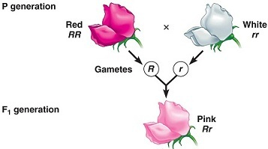In the natural world, not all traits are either dominant or recessive. When one allele for a specific trait does not completely dominate over the other allele, producing an intermediate phenotype, it is known as **incomplete dominance** (see figure below). For example, in snapdragon flowers, the heterozygous condition results in a pink color, and the homozygous conditions result in either red (RR) or white (rr) flowers.

Another condition known as **codominance** also exists. In this case, both the alleles in the heterozygous condition are equally expressed. A classic example of codominance is the ABO blood groups. In a person with type AB blood, both alleles are expressed.

**Summary**

* A Punnett square is a chart that allows you to determine the expected percentages of different genotypes in the offspring of two parents.
* A Punnett square allows the prediction of the percentages of phenotypes in the offspring of a cross from known genotypes.
* A Punnett square can be used to determine a missing genotype based on the other genotypes involved in a cross.

**Making Connections**

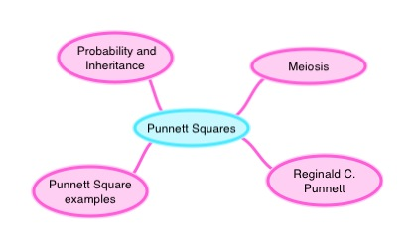

**Review**

1. What is a Punnett square? How is it used?

- The Punnett square is a square diagram that is used to predict the genotypes of a particular cross or breeding experiment. It is used by biologists to determine the probability of an offspring having a particular genotype.

2. Draw a Punnett square of a Ss x ss cross. The S allele codes for long stems in pea plants and the s allele codes for short stems. If S is dominant to s, what percentage of the offspring would you expect to have each phenotype?

3. What letter should replace the question marks (?) in this Punnett square? Explain how you know.

- The letter should be a capital B because it states that this type of Punnett square is a monohybrid cross, where each parent shares one type of allele.

4. How do the Punnett squares for a monohybrid cross and a dihybrid cross differ?

-Monohybrid Punnett squares show each parent with one type of allele, but dihybrid Punnett squares have one parent carry a homozygous dominant allele, while the other one carries homozygous recessive allele.

5. What are the genotypes of gametes of an AaBb self-pollination?

-  Both parents produce 25% each of AB, Ab, aB, and ab.

6. Mendel carried out a dihybrid cross to examine the inheritance of the characteristics for seed color and seed shape. The dominant allele for yellow seed color is Y, and the recessive allele for green color is y. The dominant allele for round seeds is R, and the recessive allele for a wrinkled shape is r. The two plants that were crossed were F1 dihybrids RrYy. Identify the ratios of traits that Mendel observed in the F2 generation. Create a Punnett square to help you answer the question.

-The ration is 9:3:3:1, as in 9 plants with round shape of seed and yellow seed color, 3 plants with round shape of seed and green seed color, 3 plants with wrinkled shape of seed and yellow seed color, and 1 plant with wrinkled shape of seed and green seed color